1.Create an array of 10 elements and print them using the for each loop.

Ans)

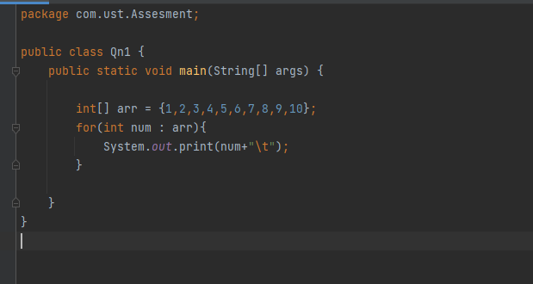

**Result**

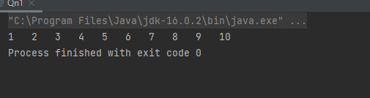

1. Take the number input from the console and add all the positive numbers. (not to consider the negative number if entered)
2. Ans)

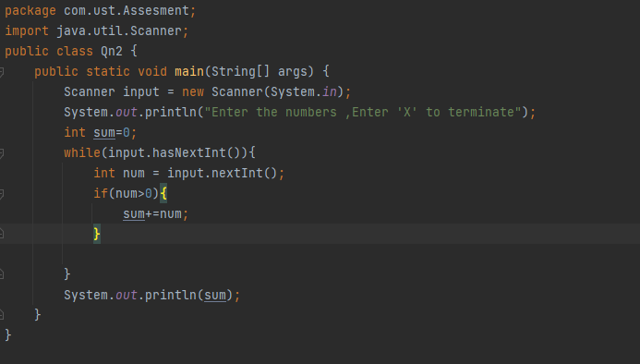

Result

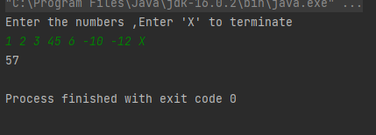

1. Create a labeled break and write a simple logic and execute the program.

Ans)

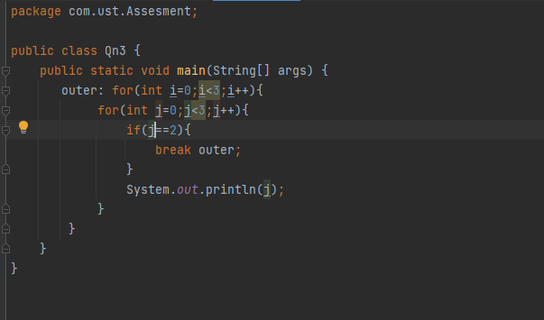

Result

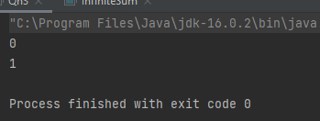

1. Do the addition of around 10 even numbers, but use the continue statement in the logic.

Ans)

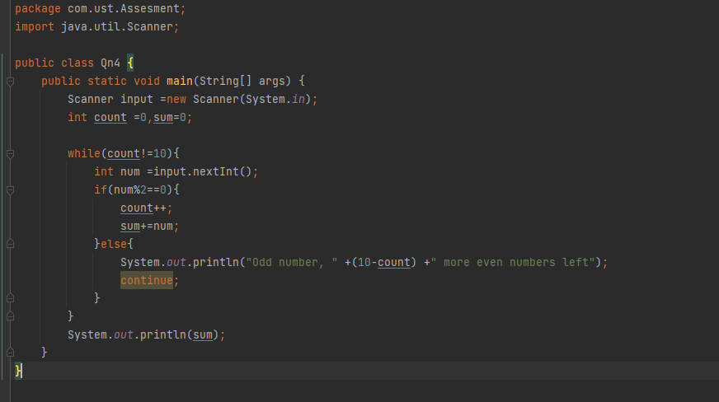

Result

